UNILEVER

Employee Health, Nutrition & Well-being
As well as being committed to protecting our employees from work-related hazards, we are also committed to promoting their health, nutrition and well-being so that they can enjoy fit and healthy lives, both at work and at home.

Targets & Performance

Improve employee health, nutrition and well-being
Our Lamplighter employee programme aims to improve the nutrition, fitness and mental resilience of employees. By 2010 it had already been implemented in 30 countries, reaching 35,000 people.
- In 2011 we aimed to extend the reach of Lamplighter to a further eight countries. We will implement Lamplighter in an additional 30 countries between 2012 and 2015. Our longer-term goal is to extend it to all the countries where we operate with over 100 people.
- We will implement a mental well-being framework globally.
New target 2014.
- Lamplighter has reached around 55,000 employees. In 2013 it was rolled out to 10 countries.
- We will report on this target in 2015.
- achieved
- on-plan
- off-plan
- %of target achieved

Our perspective
In 2012 we implemented a global No Smoking Standard for employees whilst at work. By the end of the year, compliance with the new standard had reached 72%. We reached 100% compliance in 2013.
Lamplighter is key to addressing the top three health risks we have identified across our business: mental well-being; lifestyle factors (eg exercise, nutrition, smoking and obesity); and ergonomic factors (eg repetitive strain injury).
Lamplighter helps us to analyse our employees’ health risks and to put in place steps to control them. For example, in India the programme reduced the number of employees categorised as ‘high risk’ (due to obesity or hypertension for example) from 8% to under 4% over 2007-12.
It is proving a valuable tool for safeguarding employees’ health, improving productivity and reducing costs. By the end of 2013, the Lamplighter programme had reached around 55,000 employees worldwide. By 2020, we aim to extend the reach of Lamplighter to all countries where we operate with over 100 people. We also aim to implement a mental well-being framework globally by 2014.

Our strategy
We seek to attain best practice in medical and occupational health. Our global medical and occupational health strategy focuses on health protection and health promotion and covers three key areas:

1. Health, well-being & performance – where our goals are to:
- promote the health of our employees, which brings both individual and business benefits
- roll out our employee health programme (Lamplighter) further
- promote mental well-being and resilience
- tackle local health risks such as HIV, malaria, dengue fever and tuberculosis
- ensure business continuity in the event of a health pandemic
- support the concept of ‘agile working’ for our employees.

2. Prevention of occupational ill-health – where we aim to:
- prevent work-related illness and occupational diseases
- formulate new occupational health key performance indicators (KPIs) which will measure occupational health performance
- ensure good ergonomics at the workplace
- control specific risks such as noise and allergens.

3. Travel-related activities, where we:
- provide advice on immunisation and preventative measures (chemoprophylaxis) for all business travel
- offer advice before, during and after travel.
We are developing performance measures to assess our achievements in these three areas.

Lamplighter employee programme
Improving the health, nutrition and well-being of our employees is essential for our continued business success. We believe that healthy employees contribute to a healthy company.
We have developed a global framework which Unilever operating companies are encouraged to make available to all their employees. This is the Lamplighter programme, in which employees are individually coached on their exercise regime, nutrition and mental resilience. An initial check-up is followed by six-monthly visits where progress is monitored.

Investing in employee health
We have increasing evidence that our Lamplighter health programme is a sound investment for our employees and for our business. Independent analysis shows a return on investment of €4.82 for every €1 invested in the programme in Brazil, based on combined healthcare and productivity savings over 2008-11. In Singapore the return on investment was €3:1 over 2009-12 and there has been a reduction in the health risk factors associated with higher healthcare costs, such as poor diet and fitness.

How do we encourage our employees to change their habits?
Our challenge is to encourage employees to change their behaviour and sustain new habits, through regular exercise, better eating habits and managing pressure, both at work and outside it. We have found that if we can keep employees motivated during the first six months of a programme of change, positive changes are likely to remain.
An important factor in the success of the Lamplighter programme is leadership behaviours. People at work often follow the patterns of behaviour set by their managers, so we started our roll-out with senior managers and asked them to encourage their teams to join the programme.

How do we measure the success of Lamplighter?
The single most important factor in evaluating the outcome of Lamplighter is the improved health risk status of employees. We start by determining the health risks that an individual faces. Risks are assigned to a number of factors: lifestyle (alcohol and smoking), non-modifiable (age and ethnicity), nutritional (eg consumption of fruit and vegetables), physiological (heart rate and body mass index), biochemistry (cholesterol and diabetes) and workplace (stress and engagement).
Under the programme, we rate employees as low, medium or high risk. Low risk means that a person has between zero and two risk factors – such as smoking or a failure to take any exercise. Medium risk is caused by two to four risk factors and high risk by five or more. We then educate and support people in making changes to reduce these risks. For example, in India the programme reduced the number of employees categorised as ‘high risk’ (due to obesity or hypertension, for example) from 8% to under 4% over 2007-12.

An independent evaluation of effectiveness
We commissioned the Lancaster University Centre for Organisational Health & Well-being in the UK to carry out an independent study of the effectiveness of the Lamplighter programme in 2009. The study was based on results from employees who had taken part in the programme at our London headquarters.
The analysis showed a number of significant improvements in employees’ health after participating in the programme, including positive improvements in eating habits, fitness levels and how engaged people felt at work. The Centre concluded that ‘the Unilever Lamplighter programme can be considered to be a good example of a comprehensive organisational wellness programme that incorporates both fitness and educational components, to improve individual health and well-being’.
Programmes such as Lamplighter have important short- and long-term health and business benefits. In the short term we expect to see healthier, more motivated and more productive employees, with lower levels of sick leave. The long-term benefits are in lower healthcare costs for companies and society.

Responding to pandemics & protecting employee health
Taking care of our employees’ health becomes even more crucial at times of pandemics. We have a clearly articulated plan of action to protect employee health and business continuity.
During the outbreak of the influenza A (H1N1) virus around the world in 2009 and early 2010, we implemented a co-ordinated response across all our operations.
We provided clear guidelines to our operations on how to respond to the pandemic and monitored travel in and out of the countries that were affected. We posted materials across our office and factory sites to highlight the simple steps individuals could take to protect themselves. We also made soap and hand gel widely available.
During the earlier outbreaks of avian flu, we ran business continuity exercises in countries such as Vietnam, Thailand, China, Turkey and Egypt.
The lessons learned from the outbreaks of 2009 and 2010 led to a review and a strengthening of our guidelines for managing a future flu pandemic.

Agile working
Our aim is to create a working environment supportive of employees’ personal lives, while meeting our business needs. One of the ways we do this is through agile working – giving employees the right working practices and technology to do their job anywhere, anytime, as long as the needs of the business are met. We also offer more formal flexible working arrangements such as job-sharing and flexible or reduced hours.
Read more on how we are reducing employee travel through agile working and telepresence in the Reducing office impacts section.

How are we tracking occupational health performance?
We have adopted indicators to track our occupational health performance. Our leading indicators include the percentage of people who attend a health check as a proportion of total employees, and the number of sites that pass an audit. Audits contain safety and environmental questions and have been adapted to include questions on occupational health. These audits must be signed off by the country chairman.
Our lagging indicators include the number of work-related illnesses caused or exacerbated by work, and the number of days taken off due to work-related illness.
We plan to improve our data collection by incorporating our occupational health indicators into our existing health and safety IT system. This will allow occupational health doctors to record data ‘as it happens’. Timelier reporting will also allow us to manage and reduce occupational illnesses. We plan to report globally for all Unilever sites once we are confident that the data is robust and accurate.

Tackling HIV/Aids
HIV/AIDS has an impact on our business, not only in terms of our own employees, but also in wider socio-economic terms in many of our markets.

Our approach to HIV/Aids & occupational health
Occupational health is a worldwide responsibility for Unilever and covers:
- access to primary healthcare
- protecting health in the workplace
- ensuring medical fitness for the job, and
- actively promoting health and well-being.
Unilever HIV/AIDS programmes are an integral component of our Medical and Occupational Health strategy. We have a company-wide standard to reinforce our commitment to the care and protection of employees living with the disease and to help prevent new infections. The standard underpins Unilever’s approach to prevent discrimination against employees based on HIV status and to offer care and support when needed. It is based on the principle of treating HIV/AIDS like any other chronic disease and providing appropriate steps to combat it.

Focusing on education and prevention
As there is currently no cure for AIDS, education and prevention are critical to halt the spread of the disease and are the main line of defence against it. These should also be supported by counselling and sustainable programmes to care for those already infected. Therefore, in the fight against HIV/AIDS, Unilever is committed to deploying effective programmes of health education (using our skills in communication) and to securing access to appropriate treatment for our employees at all stages of the disease.
Countries differ greatly in the quality of clinical infrastructure, in national health priorities and in the cultural sensitivities which surround HIV/AIDS. The role of the private sector varies accordingly – where public health systems prevail, for example, Unilever’s contribution will concentrate on education and prevention schemes.
Elsewhere, direct involvement in treatment and care may be necessary. Unilever's policies respond to these differences and adapt to fit local needs. In each country, health professionals are responsible for determining the mix of provision for employees in line with local cultural, social and operating requirements.
Our policies have been most developed in sub-Saharan Africa, where the company’s programmes have been developed over many years and are shared widely both with other companies and in society.
Over a decade ago we developed a roadmap for implementing our programmes of health education in the fight against HIV/AIDS. In 2010 we revised this to provide a more tailored roadmap dependent upon the HIV/AIDS risk in different countries. At the end of 2012 we published a ten-year review of our programme in HIV/AIDS.

Our approach to HIV/Aids in Sub-Saharan Africa
In sub-Saharan Africa, Unilever companies have developed a comprehensive framework to manage the HIV/AIDS programme, which addresses the needs of individuals at key stages of prevention and treatment.
These are:
- awareness (through educational programmes for all employees)
- prevention (including prevention and treatment of occupational exposures and distribution of condoms)
- acceptance of status (encouraging HIV-positive individuals to seek treatment), and
- treatment and care (including access to anti-retroviral therapy).
In the case of pregnant women, we help with treatment to prevent mother-to-child transmission. These policies are aligned with the key principles of the International Labour Organization (ILO) Code of Practice on HIV/AIDS.
Today, across our sites in sub-Saharan countries, the company offers free HIV testing, as well as education programmes to raise awareness, teach safe practices and prevent discrimination. We support the destigmatisation of HIV/AIDS through voluntary confidential testing by healthcare providers.

Raising awareness
Unilever marks World AIDS Day each year. Our sites contribute to global and national awareness campaigns using a combination of the Global Business Coalition on HIV/AIDS campaign materials and local NGO and government messages.

Global business coalition on HIV/Aids
Given the scale of the challenge, our approach is to work in partnership with others, and to share expertise and learning. Unilever was one of the founding members of the Global Business Coalition on HIV/AIDS, Tuberculosis and Malaria (GBC), which aims to mobilise the networks and resources of multinationals to combat and raise awareness of these diseases. Our Vice President for Global Medical and Occupational Health is a member of the advisory board of the GBC.

International organisations
We work with a range of other international organisations on AIDS, such as the World Health Organization, the World Economic Forum, the Gates Foundation and the Institute for Health and Productivity Management. We also take part in international conferences such as the International AIDS Conference and share our learnings with other businesses – our programmes are available as models on both the Global Business Coalition and the Global Health Initiative websites.

Regional and national coalitions on HIV/Aids
We support 11 business coalitions on AIDS across Africa (Côte d’Ivoire, Ghana, Kenya, Malawi, Mozambique, Nigeria, South Africa, Tanzania, Uganda, Zambia and Zimbabwe).
Unilever is a member of the Private Investors for Africa (PIA), a business coalition that brings together ethically like-minded companies with the objective of using their business experience in Africa to tangibly contribute to the continent’s future. A successful business requires a healthy workforce, and PIA companies work together to mitigate health risks in the workplace. A working group compiled an HIV/AIDS roadmap with key performance indicators and regularly monitors progress against this. Currently, PIA is building on the success of this initiative to develop plans to address malaria, health and safety and non-communicable diseases.
We have been a member of the South African Business Coalition on HIV/AIDS (SABCOHA) since its inception in 2007. Its aim is to co-ordinate a private sector response to the HIV/AIDS epidemic and to help companies, both large and small, in their efforts to combat the epidemic through workplace initiatives. The business environment offers a unique opportunity to target the millions of employees affected by the pandemic. We participate in SABCOHA initiatives and use this forum to share best practice with other companies.

Boosting HIV testing in South Africa
In April 2010, the South African government and the South African National AIDS Council (SANAC) announced the launch of a wide-scale HIV Counselling and Testing (HCT) campaign. This was a groundbreaking step by the government and will help to achieve the targets of the National Strategic Plan on HIV, AIDS and Sexually Transmitted Infections.
The campaign aims to encourage 15 million people to take an HIV test. The business sector will contribute to this national target by mobilising 2 million people to check their HIV status. Unilever South Africa has fully aligned its practices with the government’s campaign, which aims to encourage 15 million people to take an HIV test.
Further to this initiative, in 2012 Unilever supported an additional 20,000 tests within KwaZulu Natal (South Africa) as part of the ongoing campaign, assisted by funding from the Global Fund on HIV, Malaria and Tuberculosis.

Working with suppliers in Nigeria
Over 2007–09, Unilever, Guinness and Nigerian Breweries worked with the German organisation for technical co-operation (GTZ) to address the impact of HIV/AIDS on key suppliers in Nigeria. We conducted an assessment of how our suppliers generally perceived HIV/AIDS as well as their knowledge and workplace practices. The findings were used to select three companies who would most benefit from HIV/AIDS workplace programmes. We then helped them to develop and establish a suitable programme for their business.

Public–private partnerships
We continue our work with a variety of international agencies across sub-Saharan Africa, in particular where we are involved in primary healthcare in plantations and remote locations.

Co-investment
Co-investment is an innovative approach that consists of leveraging private sector infrastructure and assets to benefit the community beyond the company’s labour force. In Tanzania, one example of co-investment is the collaboration of the national government, various international organisations, NGOs and the private sector – Unilever Tea Tanzania Ltd – to scale up HIV/AIDS treatment.

Employee engagement
We also encourage our employees to support our efforts. For example, Unilever North America supported the 2012 AIDS Walks in May 2012. Around 150 employees took part, raising over $10,000 for AIDS research. In South Africa Unilever employees took part in the Two Oceans Marathon to raise money for a South Africa HIV/AIDS charity, Thokomala.

External recognition
In India, the International Labour Organization recognised Hindustan Unilever with a commendation certificate for the leadership it had provided in the successful implementation of the ILO’s Prevention of HIV/AIDS in the World of Work programme.
In November 2011, Unilever Germany was named winner of the German Corporate Health Award (within the consumer goods/electronic category) for its corporate health management. This annual award was presented by the Federal German Ministry of Labour and Social Affairs.
In March 2010, Unilever received the Level II International Corporate Health & Productivity Management Award, made by the Institute for Health and Productivity Management (IHPM) – a global non-profit organisation – for our Lamplighter programme. This is the highest international level of recognition available.

Employee Safety
Safety in Unilever is a non-negotiable commitment

Targets & Performance

Reduce workplace injuries and accidents
- We aim for zero workplace injuries. By 2020 we will reduce the Total Recordable Frequency Rate (TRFR) for accidents in our factories and offices by 50% versus 2008.
- Over 50% reduction in TRFR achieved by end 2013, down to 1.03† from 2.10 per 1 million hours worked in 2008, reaching our target seven years early. 12% reduction in 2013 compared to 2012.
- achieved
- on-plan
- off-plan
- %of target achieved
† Independently assured by PwC

Our perspective
We are proud to have achieved our target of halving the number of accidents in our factories and offices compared to 2008. We are amongst the leaders in our industry on safety.
We measure our progress using Total Recordable Frequency Rate (TRFR) which counts all workplace injuries except those requiring only simple first aid treatment. With the exception of 2001, we have achieved continuous improvement in our health and safety record since 1996. In 2013 we continued this progress, reducing TRFR by 12% compared to 2012, from 1.17 to 1.03 per 1 million hours worked.
Reducing road traffic accidents remains a priority for protecting our people. Much of our business growth comes from developing markets where our sales people are at increased risk from travel because the local road infrastructure can be poor.
We have been working with Cranfield University in the UK and other partners to develop a holistic approach that tackles internal risks as well as collaborating with others to address external risk factors, such as local road safety black spots.
Mapping external risks allows us to identify how they are best addressed, for example through public awareness campaigns, advocacy or by working with others to leverage our efforts and resources.

Our approach
Safety is integral to everything Unilever does. It is non-negotiable and we are relentless in our focus on improving safety through visible leadership, the positive behaviour of our people, the design of our plants, facilities and products, and by implementing safe systems and procedures throughout Unilever.

Safety in the workplace
Through our Vision Zero strategy – zero fatalities, zero injuries, zero motor vehicle accidents, zero process incidents, zero tolerance of unsafe behaviour and practices – we aim to reduce risk not only to our employees but also to the wider community in which Unilever operates. We do this through a number of programmes, one of which is Safe Travel, which helped achieve a considerable reduction in driving-related fatalities in 2013 compared with 2012.
We are committed to providing a safe workplace for our employees, contractors and visitors. As part of the Unilever Sustainable Living Plan we have set a target to reduce workplace injuries and accidents in our factories and offices.

Leadership & governance
Our commitment to safety comes from the most senior levels in our organisation. Ultimate responsibility for our safety performance rests with our CEO. The senior leader responsible for health and safety is our Chief Supply Chain Officer, who is also a member of the Unilever Leadership Executive.
Unilever has a global health and safety policy and a set of mandatory standards based on the international standard OHSAS 18001 which guide our management systems. We also have mandatory standards and best practice guidelines on individual aspects of health and safety. All these are made available to all Unilever locations worldwide on an intranet-based system. We have an IT system to collate safety data from each of our sites.
Our senior health and safety professionals meet regularly as the Unilever Group Safety and Health Leadership Team. The Team is chaired by our Vice President for Safety, Security & Brand Protection, who reports to our Chief Supply Chain Officer.
Its role includes:
- advising our Supply Chain Leadership Team on areas of focus and recommending and supporting specific improvement projects
- reviewing progress against targets and recommending specific remedial actions
- following up on serious incidents and ensuring wide dissemination and adoption of the lessons learned.
We are also emphasising that line management and individuals share responsibility for safety. Safety committees at every site carry out engagement and consultation with employees at all levels.
To reinforce our safety governance, in 2013 we established a Global Safety and Health Executive Committee (GSHEC) which is chaired by the Chief Operating Officer (COO) with membership consisting of his leadership team from the General Management Executive (GMEx). GSHEC has four sub-committees focusing on Behaviour Based Safety, Process Safety, Safe Travel and Medical & Occupational Health, each led by one of the senior leaders with membership taken from across the organisation. GSHEC reviews performance and programmes.

Premier Safety Award
Every year, Unilever awards the Premier Safety Award to the team who is making the most difference to employee safety. In 2013, our winner was India’s Haridwar factory, which has accumulated more than 19 million accident-free man-hours.
Many of Haridwar’s employees live in communities where safety isn’t a particularly strong consideration, so the team had to build a culture of safety throughout the factory. They credit their success with management buy-in, employee engagement and ownership, and personalised training. Meticulous planning, clear communication and collaboration, and rigorous execution are all essential.
As a result, Haridwar’s employees and their families view Unilever as a company that cares about them, which in turn fosters staff loyalty. The award itself also helps to raise standards as factories worldwide compete for the coveted prize.
If ever an incident or near miss does take place, Haridwar conducts a thorough investigation and puts in place an action plan to avoid future mistakes. The factory shares best practice across the business and believes that getting to zero accidents is just the beginning. Their focus now is to maintain the high standard they have set, as well as to help others in India, and then Asia and globally to reach this goal.

More on our performance

ACCIDENT RATES (1998–2013)
In 2013, our Total Recordable Frequency Rate (TRFR) decreased to 1.03 accidents per 1 million hours worked, a drop of 12% compared with the 2012 figure of 1.17.

Accident rates (1998-2013)
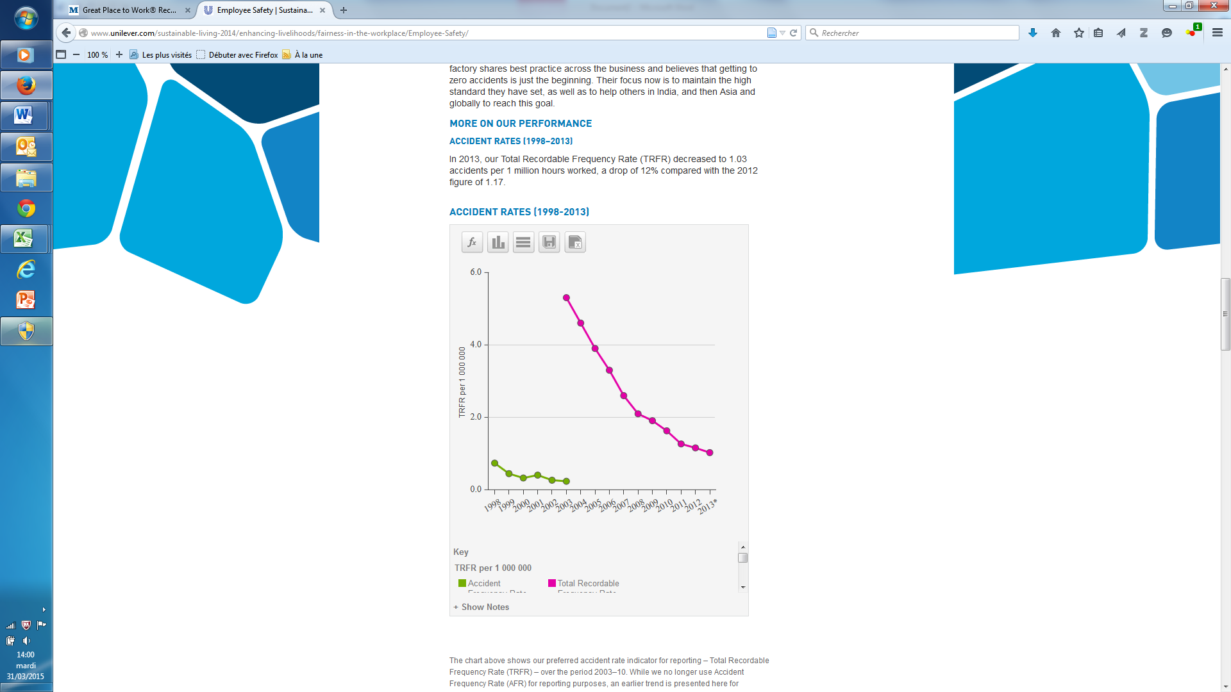

The chart above shows our preferred accident rate indicator for reporting – Total Recordable Frequency Rate (TRFR) – over the period 2003–10. While we no longer use Accident Frequency Rate (AFR) for reporting purposes, an earlier trend is presented here for comparison.
Please note that as a consequence of improving our safety performance over many years, in 2009 Unilever decided to increase the denominator used to calculate TRFR from 100 000 to 1 000 000 hours. The chart has thus been re-stated using this new, higher factor which has had the effect of increasing our current and historical TRFR data by a factor of ten.
TRFR 2013 data independently assured by PwC - see Independent assurance.
We continue to focus our support on those sites with the poorest health and safety performance.
TRFR is one of two occupational safety performance indicators that has been independently assured by PwC.
Some of our sites are achieving zero recordable injuries on an ongoing basis. For example, at our factory in Ploieşti, Romania, our workforce of 250 employees produced 70,000 tonnes of household care products a year without experiencing a single recordable injury between 2006 and 2011.

FATAL ACCIDENTS (1998–2013)
Regrettably, in 2013, two contractors lost their lives while working for Unilever. The lessons learned from these deaths were communicated across our business.

Fatal Accidents (1998-2013)
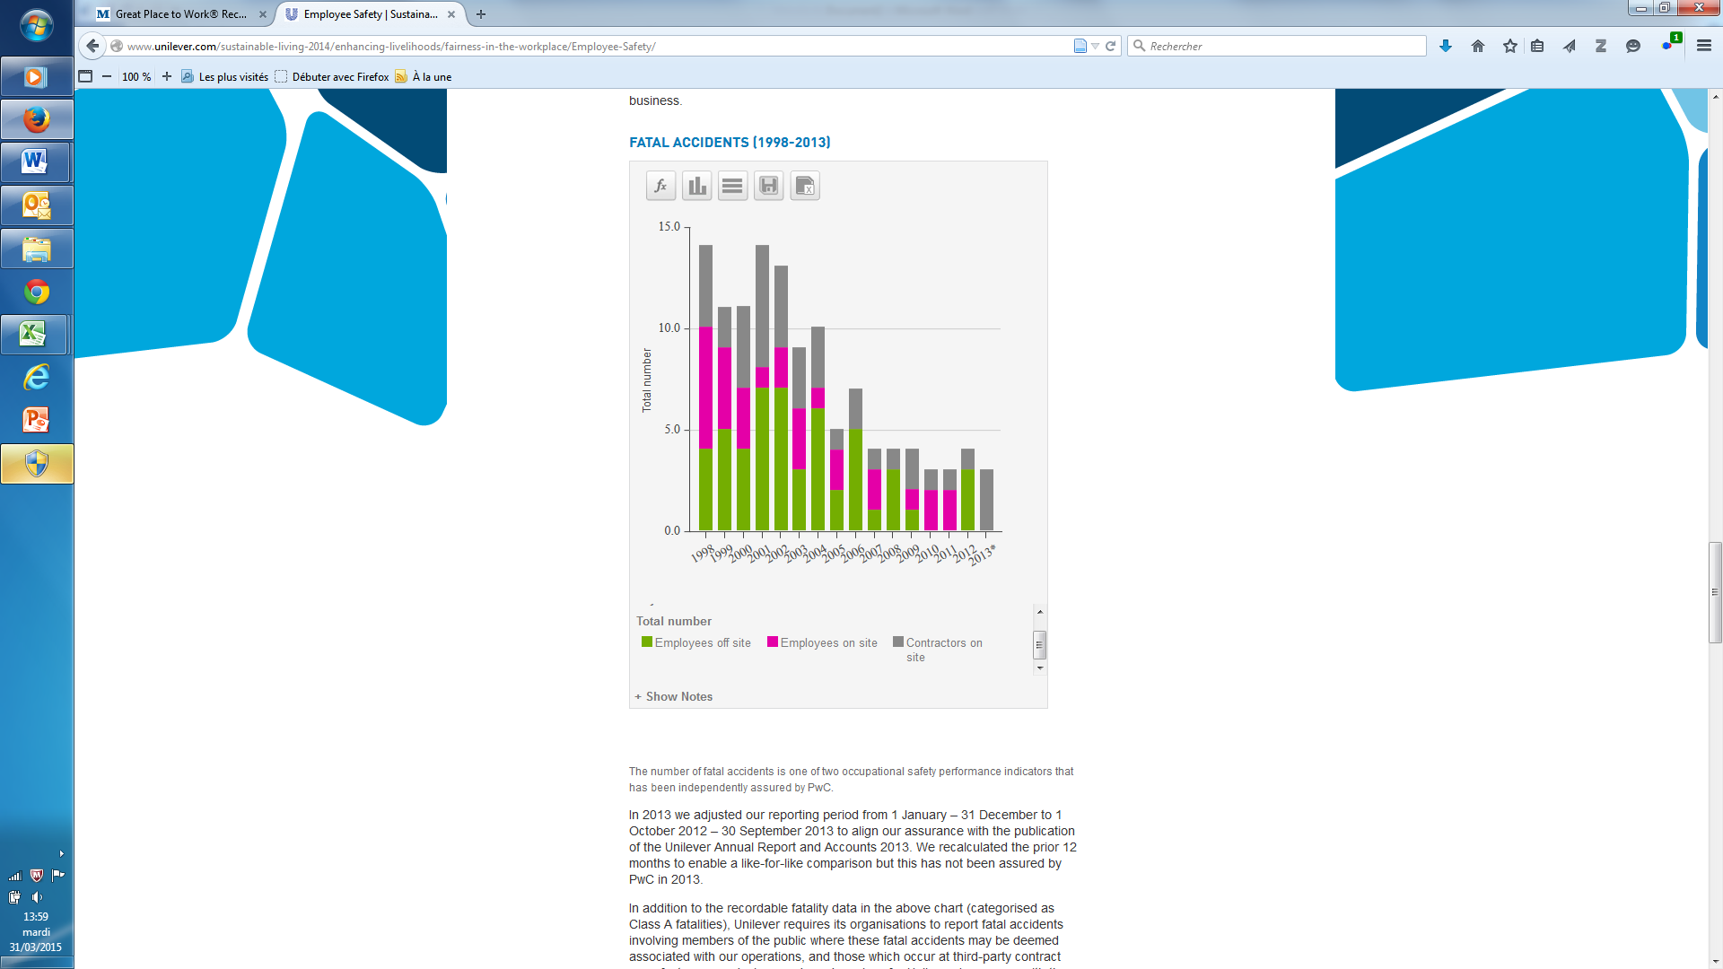

The number of fatal accidents is one of two occupational safety performance indicators that has been independently assured by PwC.
In 2013 we adjusted our reporting period from 1 January – 31 December to 1 October 2012 – 30 September 2013 to align our assurance with the publication of the Unilever Annual Report and Accounts 2013. We recalculated the prior 12 months to enable a like-for-like comparison but this has not been assured by PwC in 2013.
In addition to the recordable fatality data in the above chart (categorised as Class A fatalities), Unilever requires its organisations to report fatal accidents involving members of the public where these fatal accidents may be deemed associated with our operations, and those which occur at third-party contract manufacturers producing goods and services for Unilever. In common with the other companies in our industrial sector, these incidents are only reportable internally (Class B).
This reporting practice helps us to identify ways in which such accidents might be prevented in the future. We also benchmark ourselves against other companies in our sector and in wider industry, and work collaboratively to share best safety practice.
In 2013, we introduced the recording of deaths from natural causes and suicides of anyone within a Unilever site. These incidents are only reportable internally.

Costs of accidents
In addition to the safety of our employees, ensuring we have as few accidents as possible is important to our broader business. It is difficult to quantify the direct costs of accidents but they can affect our insurance costs, sick pay and absence cover, interrupt business activities, reduce productivity and affect employee morale and motivation.
For example, according to a study by the Health and Safety Executive in the UK, workplace injuries cost individuals, employers and government an estimated £5.2 billion in 2010-11.

Behavioural-based safety
All our regions have adopted a behavioural-based approach to health and safety. This approach recognises that best practice guidelines and policies are not enough to achieve a safe working environment. It is how well people adhere to them which makes the difference.
The example set by leadership is crucial in achieving adherence to our standards. Every manager is responsible for safety and is expected to set a personal example. We have developed new tools and training to guide our employees in adopting safe behaviours. These draw on best practice from inside and outside Unilever and are designed to encourage employees to identify unsafe behaviours and make the consequences of such behaviour more immediate and personal. In 2012 we started implementing the new tools in certain countries and have plans in place to roll out to all the countries where we operate.

Process safety
Process safety concerns the safety of manufacturing processes which can be potentially harmful, if not managed well, for example, the manufacture of aerosol sprays (because of the flammable nature of the materials used) and the refrigeration in ice cream manufacture (because of the toxicity of the ammonia refrigerant).
Our aim is to prevent any incident which would result in fatalities, serious occupational injuries or a threat to the local community, such as a major fire, explosion or leakage.
Our approach is to fully embed process safety in the way we design, develop, construct and operate our manufacturing sites. This also ensures any modifications are managed correctly.
We are undertaking a rigorous review of our approach to process safety management, to identify opportunities for improvement and build in good practice from other industries.

Machinery safety
We continue to work on improving the safety of people working with machines. We have set rigorous standards to protect our employees. We assess all the risks related to our equipment and ensure that appropriate safeguards are in place. Protective guards preventing access to moving machinery must be installed where practical and if not, interlocking guards must be used which prevent the machine from being restarted before the guard is closed. Our standards also require that machines are made safe by cutting power and locking them, before starting any maintenance or repair work.
Machinery safety is kept under continuous review and we have developed tools to involve employees in identifying hazards and assessing their risks.

Safe travel and transport
According to the World Health Organization, almost one and a quarter million people die on the world’s roads each year. This figure is expected to double by 2030, which will make it the fifth leading cause of deaths worldwide. 90% of these road deaths occur in developing and emerging markets. Due to our growth in these markets, our exposure to on-the-road risks for our employees is increasing significantly.
Safe travel and transport continue to be a priority for us. To prepare our people, we provide a risk-based driving assessment and safe travel training programme, which we developed in partnership with Cranfield University in the UK. This focuses on promoting positive driving behaviours and identifying high-risk countries where we have operations.
We have a Safe Travel committee that is led by a senior manager in all countries. These committees identify local risk, then develop and implement safe driving standards. The assessments take into account not only the specific circumstances in each country, but also the risks associated with certain routes. Drivers are provided with training based on this risk assessment. We use a combination of online training and technology, such as black boxes to track and record driving behaviour and promote safe driving techniques.
Each Unilever organisation ensures that its providers of outsourced driving services provide safe and reliable vehicles and qualified drivers. Where accidents do occur, we are keen that any lessons are learned swiftly and the findings shared throughout the company to prevent recurrence.

Updated driving standard
Unilever has introduced an updated Safe Travel in Vehicles standard that applies to all employees who drive on company business, whether full time or on an occasional basis, such as to a customer meeting or an internal event.
The main changes focus on the use of mobile phones whilst driving as well as the fitness, capability and eligibility of the driver. The updates also include responsibilities concerning local driving laws, corporate rules and the roadworthiness of vehicles.
Between 2007 and 2012, there were 40 road traffic-related fatalities involving Unilever employees on company business and members of the public, as well as over 200 injuries and more than 4,000 accidents. In many cases, a significant factor was the driver’s failure to adhere to the requirements of the Safe Travel in Vehicles standard.
The requirements will be strictly enforced, so anyone who drives as part of their job must read the Standard immediately and familiarise themselves with what they need to do.
Details on all the safe driving requirements and best practices are available on our new internal Safe Travel portal.
Where accidents do occur, we are keen that any lessons are learned swiftly and the findings shared throughout the company to prevent recurrence.

